| **Test Name** | Transmit status indicator |
| --- | --- |
| **Use Case Tested:** | Downlink command lost |
| **Test Description:** | This test verifies the transmit status indicator shows the current state of the most recent command properly. |
| **Pre-conditions** | * Pump Not Running. * System State of Pump: Not running. * ThingsBoard has not asked the pump to start. * Automatic operation is off. * No active alarms. * Transmit status indicator is green. |
| **Post-conditions** | * Transmit status indicator is green. |
| **Notes:** | This test must be run with the pump controller simulator so the delivery and content of the status messages can be controlled. |

|  | **TEST STEP** | **EXPECTED TEST RESULTS** |
| --- | --- | --- |
|  | Use the manual switch on the dashboard to send a pump on command. | * The switch is in the on position. * The in-transit indicator is yellow. |
|  | Wait 11 minutes. | * Nothing happens. |
|  | Send a status message from the simulator with pumpRunning: 0. | * The switch is in the on position. * The in-transit indicator is red. |
|  | Send a status message from the simulator with pumpRunning: 1. | * The switch is in the on position. * The in-transit indicator is green. * The Running on the dashboard LED is lit. |

|  |  |  |  |  |  |
| --- | --- | --- | --- | --- | --- |
| **Test Data Table** | | | | | |
|  | **1** | **2** | **3** | **4** | **5** |
| [Data field 1] | [data set 1 input value for field 1] |  |  |  |  |
| [Data field 2] | [data set 1 input value for field 2] |  |  |  |  |
| [Data field 3] | [data set 1 input value for field 3] |  |  |  |  |

**Results**

11/09/2020

Passed.

Step 1.

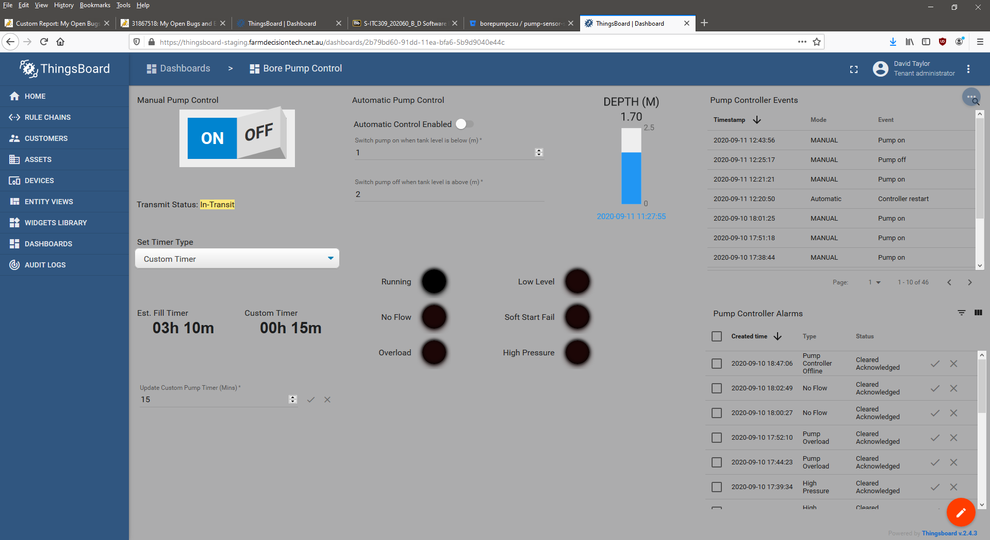

Step 3.

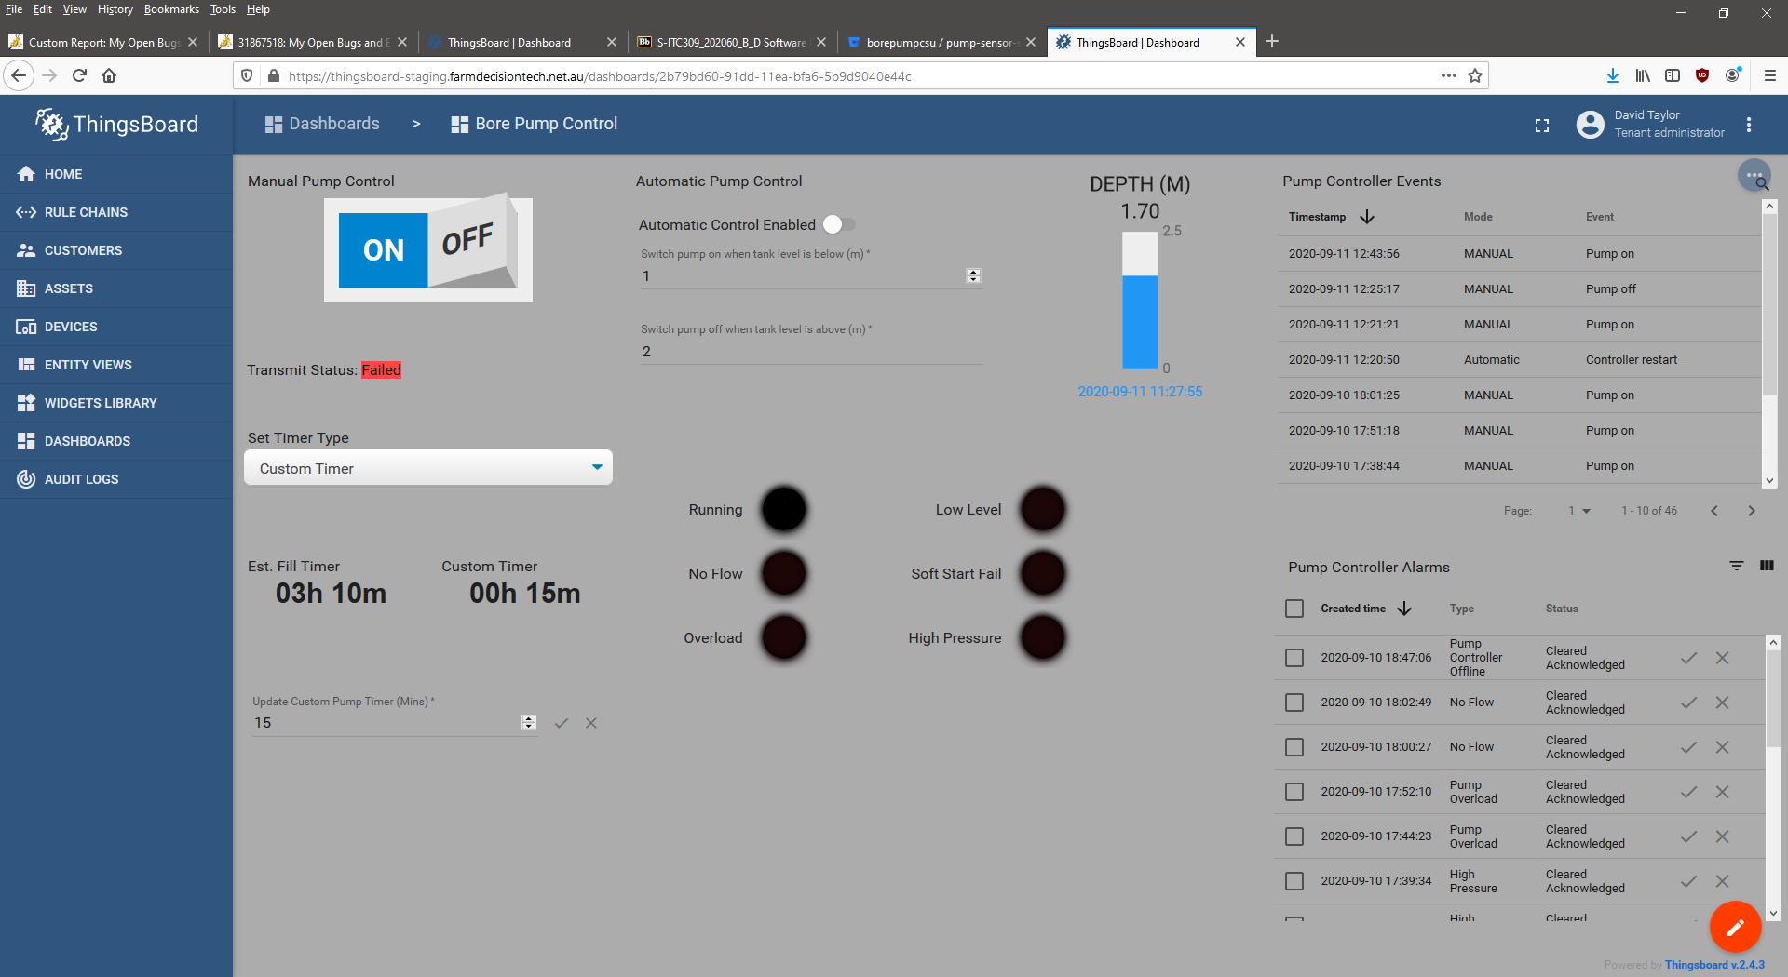

Step 4.

